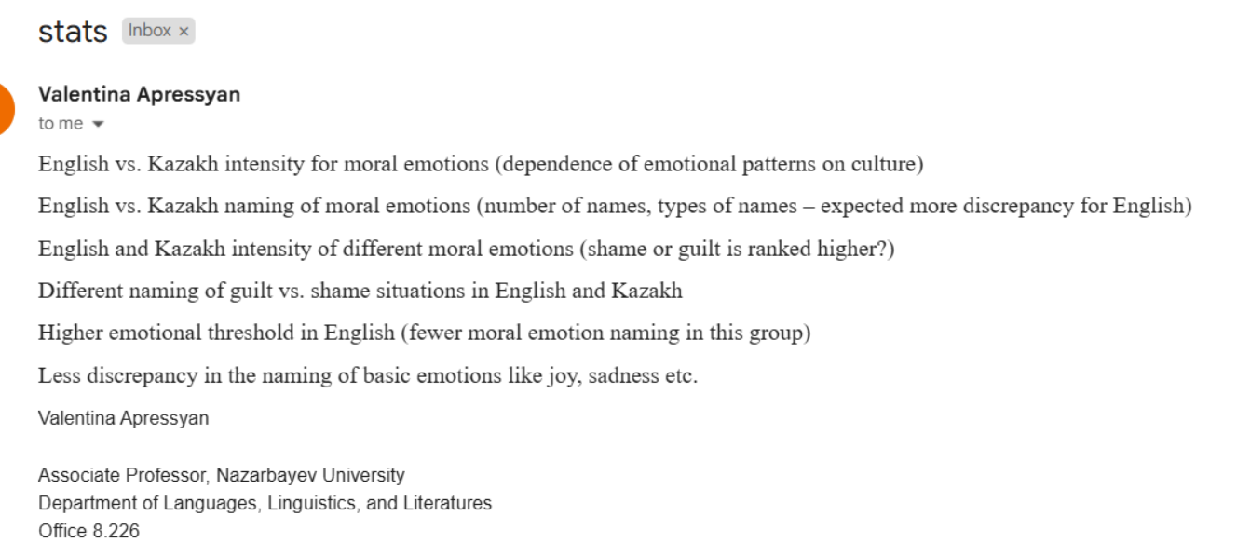

Was there a difference in naming between Kazakh and english?

Guilt:

Small harm: Kazakh vs english

| 1. **Өкініш/Өкіну/Сожаление/Regret - 44** 2. **Shame 5** | **Regret/Regretful - 26**  **Guilt 17** |
| --- | --- |
| 1. Sad 28 2. Regret 18 | 1. Disappointment 21 2. Sad 12 |

English vs kazakh

| 1. Guilt 10 2. Happy 7 3. Shame 4 | 1. Happy 13 2. Nothing 7 3. Shame 7 |
| --- | --- |
| 1. Sad/Sadness - 20 2. Grief - 10 3. Guilt - 6 | 1. Қайғы-Sad - 13 2. Өкініш-Regret - 6 |

Big harm:

Kazakh vs English:

| **Өкініш- regret 28**  **Қорқыныш+үрей -fear 13** | **Guilt 11**  **Regret 16** |
| --- | --- |
| 1. **Өкініш-Regret- 34** 2. **Кінә-Guilt 16** | **Guilt 26**  **Regret 19** |

English vs kazakh:

| 1. **Guilt / guilty**: **20** 2. **Regret / regretful**): **17** 3. **Sad / sadness**: **12** | 1. **Өкініш-Regret**  – **33** 2. **Қайғы-Sad** – **19** 3. **Кінә / Кінәлі-Guilt** – **7** |
| --- | --- |
| 1. Guilt/Guilty - 16 2. Regret - 10 | 1. **Кінә/Кінәлі/Кінәлілік - 27** 2. Өкініш/Өкіну - 18 |

Discrepancy.

Do the right sorting of the emotions to moral and non–moral

Talk more ab the intensity differences

**Average intensity of the moral emotions in shame situations:**

|  | Kazakh SOCIAL shame.  Barefoot woman | Kazakh SOCIAL shame.  Telegram joke | Kazakh  MORAL shame  1990s/  Great Depression | Kazakh  MORAL shame  Mall | English SOCIAL shame  Overwhelmed | English SOCIAL shame  Alex  (lost her job+overweight) | English  MORAL shame  Angry man | English  MORAL shame  Fake dating | Contrasting pairs intensity  Shame  Stealing | Contrasting pairs intensity  Shame  Cheating |
| --- | --- | --- | --- | --- | --- | --- | --- | --- | --- | --- |
| American participant | 4.0 | 3.17 | 3.15 | 3.48 | 4.25 | 4.0 | 4.12 | 4.51 | 4.5 | 4.04 |
| Kazakh participant | 4.0 | 3.0 | 3.0 | 3.79 | 4.0 | 3.0 | 3.97 | 4.17 | 4.58 | 4.06 |

**Average intensity of the moral emotions in guilt situations:**

|  | Kazakh small harm  Guilt  Athlete | Kazakh small harm  Guilt  Lazy husband | Kazakh  Big harm  Guilt  Syria | Kazakh  Big harm  Guilt  Young mother | English  Small  Harm  Guilt  Pet | English  Small  Harm  Guilt  Make up store | English  BIG  Harm  Guilt  Babysitter | English  BIG  Harm  Guilt  Sick Partner | Contrast Pairs  Stealing | Contrast Pairs  Cheating |
| --- | --- | --- | --- | --- | --- | --- | --- | --- | --- | --- |
| American participants | **4.5** | **4.25** | **4.58** | **4.77** | **4.22** | **2.86** | **4.5** | **4.9** | 4.09 | 3.83 |
| Kazakh participants | **5.0** | **3.0** | **5.0** | **4.47** | **4.5** | **2.45** | **4.0** | **3.75** | 4.09 | 3.5 |